IT 320 Fall 2018

Team Members  
Robert Paredes-Matos – Graphics Designer, IT  
Laura Stewart – Organizer, Documentation, Network Security  
Andrew Balsom – Team Meeting Documentation, IT  
Patrick Charette – Flow Model Specialist, CS

Tuan Nguyen – Step-By-Step Task organizer, CS & IT

The Scoop

Project 4: Design



# Persona

Brian is a 29-year-old manager for a medical practice. He works long hours, plenty of overtime, and is generally too tired to do more than eat and sleep when he gets home. He does check his phone for twitter feed and news articles, but is often quietly frustrated by the lack of fact checking being done, how many articles, even from supposedly respectable news sources, are not even putting any links, references to where information come from (i.e. bibliography), or whether or not a person interviewed was selling a point of view along with whatever context they were there to provide.

He isn’t much of a complainer; most people don’t even know he checks the news, and he puts on a friendly, outgoing persona when at work. However, he is disturbed at what seems to him the undermining of knowledge, facts, and information. He feels he is both being lied to in general, and, when it comes to whatever is assumed about his politics, pandered to, and appreciates neither.

It all makes him feel a little lost and detached from a world he feels is deceiving him in one form another. He wishes he knew of a way to check news and get the most factually accurate articles without doing an absolute tone of research that he simply doesn’t have time to do. He is stuck in limbo; unable to trust the information hand fed to him, but unable to get time to do the kind of fact-checking needed to get at truth. The news, as far as he can tell, is selling some kind of point of view and the truth has gone out the window. Trust has been broken, so unless a faster, more viable method of fact checking becomes, he will never trust anything he reads again.

# Ideation

**Thought questions to get started**:  
What do news articles consist of? How do people interact with news in real life? How much is the fake news phenomena affecting their ability to trust news articles even from genuine news sources?

News articles consist of talking about what has happened, sorted by a given genre (World News, Politics, Current Events, etc.)

News articles can be informative, thought provoking, and can help drive change in some situations. News represents information that is not easy for a person to get in their day to day lives.

**Possible Features/ Breadth of Coverage**:

* Offline feature for downloading articles
* Custom search
* Share articles to social media
* Rate articles 1 to 5 stars
* Links to articles like preview article shown
* Author’s biography to look through their history
* User custom selects genres

**Ontological Artifacts**:

Phones, Tablets, Computers, Website, Application/Web Server, Application Software, Algorithm, News Articles, Search Bar, Share to Social Media Icon, Rate 1-5 Stars Icons, Icon representing links to articles like the one shown on preview square.

**Types of Genres**:

* Technology
* Medicine
* World
* United States
* Political

**Special Themes and Motifs**:

Motif for The Real Scoop could be, “We fact-check the news, you get back news you can trust,” and this could inform a sharp, serious, but overall rich in color design and scheme, between the preview squares, Icons, and hover effect on said Icons.

**Business Considerations**:

* Free in app store
* Ad free
* Anti-tracking software
* IT Infrastructure/Redundancy
* Security
* Overhead costs given above items

**Emotional Impact**:

* Customizable profiles
* Users can trust the article they read
* Less stress for the user
* Receive local articles from your location
* Can share articles important to them to social media platforms
* Why would people use this?
* To receive news that is based on facts

**Other Desired Impact**:

* Time saving (no exhaustive fact checking for user)
* Tailored user experience; genre(s), search bar

**Where to get access**:

* Google Store
* App Store
* In many web browsers via website

**Future Considerations**:

* Adding multiple languages
* Expanding to other countries
* Cloud Integration
* Offline caching capability

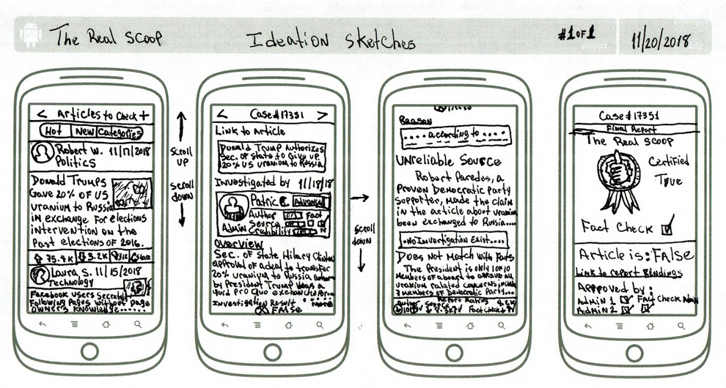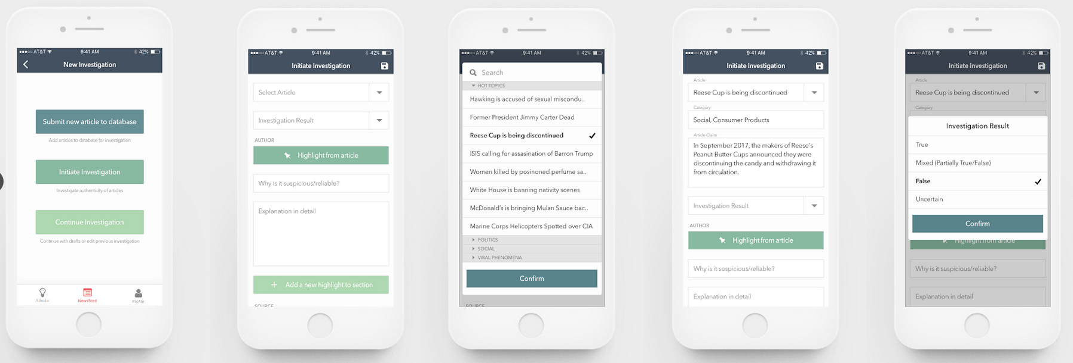

# Designer Mental Model

The purpose of the news article reading app, The Real Scoop, is to provide readers with the best news articles (best meaning most factually accurate) from popular news and media sources (NY Times, Washington Post, Boston Globe, MSNBC, BBC, etc.). Users can be from anywhere around the world, and news articles can be from anywhere around the world. The news articles are chosen carefully based on user’s genre as well as what they searched for via keywords. These articles are fact-checked and researched, and those who come out verified to be the most accurate are returned to the user to read.

By having the search term function built in, the user has the option not only to choose up to three genres, but, if unsatisfied with returned articles, can use this feature to refine the search by keywords; additionally, they have the option to not chose a genre and merely use the search functionality based on the user input. This process involves user input, checking user input for typos, nonsense words, etc., feeding it to the web/application server which then goes out, searches for articles based on these terms, checks keywords in article, checks article source to see if article is hosted on a blog/special interests site, checks for references (if none found, article rejected), links to references, checks data attributed in references, if bibliography provided, performs same check against what websites host of said bibliography, checks the data against other data/data sets out on the web, etc.

The top three most factually correct articles are returned to the user based on the user’s personal options, 5, 1 sub result below:

1. The user chose only one genre:

* The user gets three article preview screens that show the top three most factually correct articles based on said single genre.

1. The user only choses 2 genres:

* The user gets three articles, the first two based on their first choice of genre, the last one based on their second choice of genre.

1. The user choses three genres:

* The user gets one preview article square per genre, with the first one being based on first choice, second one being based on second choice, and so on.

1. The user choses to forgo the genre option and only uses the search bar:

* The user gets the top three articles that most accurately fit within their input parameters and are the most factually accurate.

1. The user choses between 1 and 3 genres and uses the search bar in order to narrow down/refine search results:

* The user gets articles based on their genre choices and refined by their search keywords that are the most factually accurate.

# Conceptual Design

The purpose of the news article reading app, The Real Scoop, is to provide readers with the best news articles (best meaning most factually accurate) from popular news and media sources (NY Times, Washington Post, Boston Globe, MSNBC, BBC, etc.), and users can be from anywhere around the world. The news articles are chosen carefully based on the user’s chosen genre(s) as well as what keywords they searched (Patriots vs Cowboys final score, keto diet latest research, etc.), fact-checked and researched, and those who come out verified are returned to the user to read.

With the ad prevention technology, the user will have the experience of searching for articles based on genre/keywords and getting back the article and reading it faster than rocket as well as not worrying about tracking cookies or adware. Moreover, the user has the option to share their favorite article to various social medias such as Facebook, Twitter, Tumblr, and Reddit.

    The process is as follows: The user downloads the app from Google Play or App Store and opens it. If the user does not have an account, they have to create one. They will have to enter a username, email, and will be asked to pick a genre (optional). After that, the user will be asked for a mobile number in order to perform 2-step authentication in which the user will receive a text with a code number. User will then enter the code, and if the code is correct, the system will transfer the user to the main screen of the application. In the main screen, the user will have 2 options; they could search for what they like such as “Ryan Reynolds Pikachu”, or scroll down and look for trending newspapers based on their genres such as “Philadelphia Eagles lost to the Saints”, for Sports.

In the first option, if the user cannot find the news articles that they want, they could enter more keywords to narrow down the types of news articles they like. However, they have to enter a starting search of keywords in the search bar, before entering any additional keywords in the search bar. If the user enters some nonsense words, the app will tell the user there was nothing found and guide the user back to the main screen. Either option leads to the user getting a top three of articles returned to them to read. At the bottom of the preview square for the article, there are some features such as sharing said article to the social media platforms mentioned above, showing related news articles, and the ability to rate articles, from best to worst, as well as showing details about the news source, like about the author, how long author has been with the news source, and the date news article was written.

Compared to other news article reading apps that have a bunch of ads and track people’s activity, our news app will have various features that please users, including ad blocking technology, and anti-tracking technology. Our app could be a bridge between readers and writers where readers could rate a writers’ news articles based on our rating system. The interaction between our news app and the user involves a network of servers and databases, with the plan to provide cloud integration in the future, while maintaining security on the network, system, and application levels in order to facilitate secure transfer of user data back and forth in the system. This is done with machine learning, A.I., deep learning, well organized IT Infrastructure (Security, Networks, and Systems), and so on. Ecologically the environment consists of an app where the process of interaction between users, the news application, and the system occurs.

In summary, we are designing a system that goes out, collects a large amount of news articles/media, and using a data cleaning process, returns to the user the most factually correct articles found based on user input in search fields and/or genre. Should have minimum time requirement of user interaction to produce desired results.

* User downloads App from Google Store, or Apple Store
* User opens the App, and along with the welcome screen, gets basic instructions on how to use the App to get the most optimal results as well as the Create an Account screen, which is not optional, but is not high maintenance either.
* In the Create an Account screen, user provides Username, Password, Email, along with the option to pick genre(s); if not wanted at the time, will have the Skip This Step option.
* User will be asked to provide a mobile number in order to get a text with a code number inside in order to facilitate a 2-factor authentication.
* If authenticated, the user will be taken to the normal main screen of the application where they’ll have two options; search via keywords “Celtics vs. Jazz final score”, for Sports, or to scroll through the news articles provided to them based on their choice of genre(s) (up to three genre choices available), and lets them look for articles on Sports, Current Events, Nutrition, etc.
* User can refine search by entering more keywords
* User can share articles they like across four different social media platforms
* User will have the ability to see related news articles (hover over/click on the  icon effect), and the date the articles were published
* User will have the ability to rate articles from best to worst (hover over/click on the ★ icon, 1 star – 5 star effect)
* User will have the option to read about the news source, like about the author, and how long author has been with the news source.

## 

## Ecological Design Sketches

## Interactive Design Sketches

## Emotional Impact Design Sketches

# Storyboard and Wireframes

## Storyboard

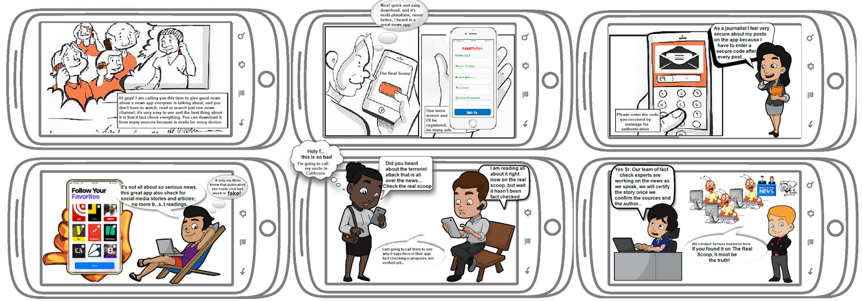

## Wireframes

